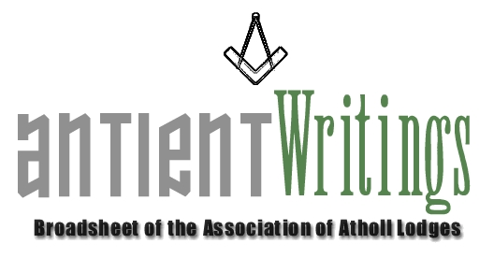

3rd Edition, 2007

New Blood

Are you !!! - Interested in joining the Executive Committee, which meets 3 times a year in London with the possibility in future of having one meeting out of London? Please make contact with the Secretary who is always keen to involve new blood and share common antient interests with Atholl brethren. Additionally the Committee will soon be actively succession planning for experienced brethren to take on the roles of:
- Secretary
- Asst Secretary [Membership]
- Directors of Ceremony [x2]
- Events Organiser
It is hoped that many of the Atholl lodges will respond to this appeal and put forward willing brethren to maintain the momentum of the Association through its Executive Committee.

Annual General Meeting

The 2008 Annual General Meeting will be held at Clerkenwell Masonic Centre London on Wed 2nd July starting at 6pm. All are welcome so please send along a representative. There will be a soiree with ‘nibbles’ at 4.30pm. Should any subscribing lodge wish to bring forward a ‘Notice of Motion’ please submit it in writing to the Secretary by 4th June 2008.

Visit to Jamaica – May 2008 – See Reverse

VISITING ROYAL LODGE No207 [5/5/08] and FRIENDLY LODGE No239 [13/5/08]

HOSTED By R.W.Bro. AFEEF LAZARUS – DISTRICT GRAND MASTER

Web Site - www.antients.com and webmaster@antients.com

The website has had a make over and Neil, the webmaster, is keen to enhance the ‘Regions’ pages to include ‘info’ and ‘chat’ from any Atholls around the country. Please send any submissions to him [above]

Midlands Meeting

It has been suggested that one of the Executive meetings be held ‘around the country’ and to that end it is hoped to arrange one for the Midlands sometime in the future, maybe October 08. Would any lodge interested in hosting such a meeting please make contact with the Secretary to facilitate planning and maybe give consideration to ‘bolting’ to it some other local event. A talk or meeting perhaps!

Would Secretaries and Representatives photocopy and distribute as widely as possible

Paul Gardner - 39 Wentworth Drive, Bedford, BEDS, MK41 8QA - 01234 261584 secretary@antients.com

